
Gasoline’s New Math
Content Area:
Basic arithmetic
problem solving

Standards met:
NM-NUM.9-12.2
NM-ALG.9-12.2
NM-PROB.PK-12.2
NM-PROB.COMM.PK-12.1

Time required:
10 – 20 minutes

Materials: (per student)
Calculator

Teacher Background Information: This lesson introduces students to the concepts of miles per dollar. Make sure that your students understand miles per gallon, or how gas efficiency is currently calculated before you introduce this new concept. It is also an opportunity to show students that math is a developing art as new measurements are used to fit new situations so that mathematicians can be helpful in solving global problems.
You may want to talk about some now defunct measurements that mathematicians used to use - see attached sheet for some defunct and some just plain funny units of measure.
Goals: To use information about gasoline to assess or review students’ ability to solve word problems involving basic arithmetic operations, and to analyze and interpret their results.
Objectives: Students will…
- Understand the concept of miles per dollar
- Solve word problems using basic arithmetic operations
- Analyze and interpret results
Prep:
- Familiarize yourself with the concept of miles per dollar

Procedure:
- Hand out the article “Gasoline’s New Math: Miles per Dollar” or have the students read the article directly off the webpage at http://editorial.autos.msn.com/article.aspx?cp-documentid=461093
- Review the ideas in the article and check for understanding.
- Hand out the student worksheet

Gasoline’s New Math: Student Worksheet

Name: ___________________________________ Class period:_________
Miles per gallon is no longer the king of the road. Move over for ‘Miles per dollar’ (mpd). Miles per dollar really puts those trips to the mall using your car in a different light. How much is each trip costing you?
The formula: Take the old miles per gallon and divide by the cost of the fuel. For example, if your car gets 20 mpg and the price of gasoline is $4.00 per gallon, then you are getting 5 mpd. Want to borrow your parents car to go to the mall (15 miles round trip)? It will cost you $3 in gas alone. Warning: Your parents will like this new math.
Determine on average the price of a gallon of gasoline in your area. Using this fuel price, determine the mpd for each vehicle in the tables (below and on the next page) and complete the tables.
Vehicle | Combined MPG | Fuel Price | Miles Per Dollar (MPD)
Toyota Prius | 46 | $
Honda Civic Hybrid | 42 | $
smart fortwo | 36 | $
MINI Cooper | 32 | $
Toyota Yaris | 32 | $

Vehicle Combined MPG Fuel price Miles Per Dollar (MPD)
Jeep Grand Cherokee SRT8 | 12 | $
Mercedes-Benz ML63 AMG | 12 | $
Mercedes-Benz G55 AMG | 12 | $
Dodge Ram 1500 | 14 | $
Lincoln Mark LT | 14 | $

Word Problems:
- On her 17th birthday, Bethany was given her 87 year old, great grandmother’s car (Her Great Grandmother has to use public transportation now because she is on a fixed income.). The 1992 Oldsmobile Cutlass is in pristine condition, with only 37,000 miles on the odometer. After a few weeks of driving, Bethany determines that she can drive 225 miles on one tank of gasoline (16 gallons). Use the current price of gasoline in your area to determine the miles per dollar for Bethany’s car. Show all of your calculations.

- What can Bethany do, concerning how she uses her car, to save as many of her precious few dollars that she has?

- Is miles per dollar best used by automobile dealers or by the consumer? Explain your reasoning for both groups.

Gasoline’s New Math: Student Worksheet – Teacher Answer Key

Name:_______________________________ Class period:_________
Miles per gallon is no longer the king of the road. Move over for Miles per dollar (mpd). Miles per dollar really puts those trips to the mall using your car in a different light. How much is each trip costing you?
The formula: Take the old miles per gallon and divide by the cost of the fuel. For example, if your car gets 20 mpg and the price of gasoline is $4.00 per gallon, then you are getting 5 mpd. Want to borrow your parents car to go to the mall (15 miles round trip)? It will cost you $3 in gas alone. Parents will like this new math.
Discuss with your class the price of a gallon of gasoline in your area (maybe even determine the average price per gallon in your area.) Using this fuel price, determine the mpd for each vehicle in the tables (below and on the next page) and complete the tables.
Vehicle | Combined MPG | Fuel Price | Miles Per Dollar (MPD)
Toyota Prius | 46 | $ 3.00 | 15.33 (46mi/$3)
Honda Civic Hybrid | 42 | $ 3.00 | 14.0 (42mi/$3)
smart fortwo | 36 | $ 3.00 | 12.0 (36mi/$3)
MINI Cooper | 32 | $ 3.00 | 10.67 (32mi/$3)
Toyota Yaris | 32 | $ 3.00 | 10.67 (32mi/$3)

Vehicle Combined MPG Fuel price Miles Per Dollar (MPD)
Jeep Grand Cherokee SRT8 | 12 | $ 3.00 | 4.0 (12mi/$3)
Mercedes-Benz ML63 AMG | 12 | $ 3.00 | 4.0 (12mi/$3)
Mercedes-Benz G55 AMG | 12 | $ 3.00 | 4.0 (12mi/$3)
Dodge Ram 1500 | 14 | $ 3.00 | 4.67 (14mi/$3)
Lincoln Mark LT | 14 | $ 3.00 | 4.67 (14mi/$3)

Word Problems:
- On her 17th birthday, Bethany was given her 87 year old, great grand mother’s car (GGM has to use public transportation now because she is on a fixed income.). The 1992 Oldsmobile Cutlass is in pristine condition, with only 37,000 miles on the odometer. After a few weeks of driving, Bethany determines that she can drive 225 miles on one tank of gasoline (16 gallons). Use the current price of gasoline in your area to determine the miles per dollar for Bethany’s car. Show all of your calculations.
225 mi/16 gal = 14.0625 mpg
14.0625 mi/1 gal x 1 gal/$3.00 = 4.6875 mpd ≈ 4.69 mpd

- What can Bethany do, concerning how she uses her car, to save as many of her precious few dollars that she has? (Answers will vary.)
Combine trips, keep tires inflated properly, drive the speed limit or below, etc.

- Is this ratio of miles per dollar best used by automobile dealers or by the consumer? Explain your reasoning for both groups.

If at all, the consumer would benefit the most. The problem is that this ratio will change with the ever-changing price of gasoline, making the need to recalculate on an almost daily basis.

Gasoline's New Math: Miles Per Dollar
It's time to look at gasoline, and our national chug-a-lug habit, in a new way.
By Lawrence Ulrich of MSN autos
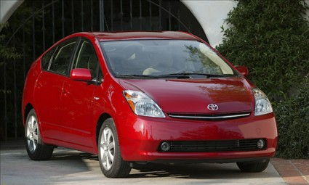

Toyota Prius is the most fuel-efficient car in America at about 45 mpg. But using this new calculation, it gets a mere 15 miles per dollar.

For decades, miles per gallon — mpg in its familiar shorthand — has been the only way for consumers to understand how much gasoline is going into their tank, and what it really costs. But mpg isn't cutting it.

Like leagues, fathoms and pecks, mpg has become a relic, a unit of measure that has lost its meaning. It's a quaint reminder of the days when a gallon of high-test cost a buck or less, and Jimmy Carter donned his fuzzy cardigan and kindly asked everyone to crank down the thermostat and conserve energy.

It's time for new rules, and new math: Miles Per Dollar, or mpd.

The formula is simple. Take the old mpg, but divide it by the price of fuel. Unlike the vague mpg, mpd is a remorseless measuring stick, its pointy end aimed directly at your wallet. When gas was cheaper than the dirt it sprang from, 20 miles per gallon seemed pretty solid. Even when gas reached a dollar a gallon, you were still getting 20 mpd, traveling 20 miles on a buck.

The problem is that, as a whole, the nation's cars and trucks aren't getting any better fuel economy than they were 20 years ago. With the price of a gallon of gas soaring to $3 and beyond, think again about that 20 mile-per-gallon car. Its mpd rating has fallen to less than seven.

For a fun new road game, just count the mile markers. Every time you reach seven, you just blew another dollar. If your family hauler gets 7 mpd (or 21 mpg) on the highway, cruising at 70 mph costs a mind-blowing $10 per hour in fuel, more than some people make at their jobs. If that doesn't make you want better mileage, I don't know what will.

Now, a skeptic might call my mpd formula flawed or complicated, because it fluctuates with the price of gasoline. But that's precisely the point. As gas prices pole vault to new heights, mpd grabs you by the collar and says, "Um, buddy, have you seen how much you're spending to drive to Dairy Queen and back?"

It doesn't help that the government and car companies have fudged on miles-per-gallon ratings for years, confusing and misleading consumers. The Feds finally created a more realistic real-world mileage test that's in effect for 2008 models. Under the new test, a four-cylinder 2008 Honda Accord — an efficient sedan if ever there was one — gets 21 mpg in the city, 31 highway, and 24 mpg overall.
Put that Accord under my mpd microscope, and you're getting just 8 miles per dollar. At 3 bucks a gallon, the Toyota Prius, the most fuel-efficient sedan sold in America at about 45 mpg, manages a mere 15 mpd. If gas hits $4 a gallon, even a Prius will be burning through a buck every 11 miles.

Over at the Union of Concerned Scientists, the policy group was celebrating the recent passage of an energy bill that will boost the nation's cars and trucks to 35 mpg by 2020, a nearly 40-percent economy jump. Eli Hopson, Washington spokesman for the scientists' Clean Vehicles Program, called the bill a watershed moment. "It's the first major action to reduce our oil use and global warming pollution in nearly 30 years," Hopson said.

The bill is indeed historic stuff, and an increase was long overdue to spur automakers (not just Detroit, mind you, but Toyota, the Germans and the rest), to get serious about fuel economy. Getting serious goes for consumers as well. Since the first fuel-economy standards were written in the '70s, Americans have shown little inclination to buy smaller, fuel-efficient cars.

It's easy to point fingers at the government, car makers and oil companies, but there's no free lunch. The Feds can regulate all they want, but you can't have a three-ton, 400-horsepower SUV and get 50 mpg with a cherry on top. You hate to say it, but it seems like pain at the pump has to get even worse to pry Americans' hands off their gas guzzlers.

The Union of Concerned Scientists isn't ready to leave miles-per-gallon behind (give 'em time, I just sprung the idea over the phone). But Hopson agreed that thinking about fuel use in mpd could be a worthwhile step. "Using those kinds of numbers to make people realize the true cost of driving is an important step," he said. Not just to drive home the need for efficient cars, but the need for conservation all around.
My longtime theory is that gas pumps that accept credit cards have made it only too easy to pour money down the black hole of your gas tank. If you were forced to whip out a $50 bill (or more), every time you filled up, the shock waves emanating from your wallet or purse might be impossible to ignore.

It happened to me a few months ago, when a station's credit-card machines were on the fritz and the fuel gauge of the heavy-duty pickup truck I was driving was practically on empty. Watching the pump dials spin, I felt like a Vegas gambler who knew that his luck had run out. By the time I was done, some 28 gallons later, I had set a new personal record with a $90 fill-up. Ouch.
Historical, now defunct, Units of Measure
barleycorn | old unit of length equal to one-third inch
butt | unit of volume equal to two hogsheads or 126 gallons
clove | old weight of seven to ten pounds for wool or cheese
millihelen is the amount of beauty which can launch one ship – named after Helen of Troy
microcentury Unit of time introduced by Enrico Fermi as the "standard" duration of a ecture period equal to 52 minutes and 35.76 seconds

Funny Units of measure:

Couric: Unit of measure coined by the TV show “South Park” to denote the weight of human excrement.
Kilomockingbird:Unit equal to 1000 mockingbirds
Ratio of an igloo's circumference to its diameter: Eskimo Pi
2000 pounds of Chinese soup: Won ton
Time between slipping on a peel and smacking the pavement: 1 bananosecond
Half of a large intestine: 1 semicolon
1000 aches: 1 megahurtz
Basic unit of laryngitis: 1 hoarsepower
Shortest distance between two jokes: A straight line
1 million microphones: 1 megaphone
1 million bicycles: 2 megacycles
10 cards: 1 decacards
The force of 1 kilogram of falling figs: 1 Fig Newton
1 millionth of a fish: 1 microfiche
1 trillion pins: 1 terrapin
8 nickels: 2 paradigms
2.4 statute miles of intravenous surgical tubing at Yale University Hospital: 1 I.V. League
Gas in My Town
Content Area:
Linear Algebra
Graphing
Distance formula
Writing equations of a line using two points.

Prerequisites:
Pythagorean Rule
Graphing Ordered pairs

Standards met:
NM-NUM.9-12.3
NM-ALG.9-12.4
NM-GEO.9-12.3
NM-GEO.9-12.4
NM-DATA.9-12.1

Time required:
1 45-60 minute class period

Materials: (per student)ne
- Overhead transparency
- Graphing paper
- Computer and Internet access

Teacher Background Information: This exercise practices linear algebra skills against the backdrop of your local community map.
Goals: To use critical thinking and the distance formula to find distances from your school to other locations of interest.
Objectives: Students will…
- Identify locations using ordered pairs.
- Calculate distances using estimation and
distance formula.
- Use point data to write equations for the lines connecting two points.

Prep:
- Go to google maps.
- Download a 2000ft/500m scale map of your community.
- Center the map so that it shows your school and attendance area neighborhoods.
- Print out enough maps so that each student can have one to work with.
- Make transparency overheads with graphing paper printed on it.

Procedure:
- Ask students how long it takes them to drive to school and approximately how many miles they think they drive in an average day.
- Hand out the student sheet and a copy of the google map to each student.

Google My Town: Distance
Student Worksheet

Name:____________________________________ Class period:______
In this activity you will explore your town using distance formulas, linear algebra and Google Maps.
Step 1: Take a look at the Google map of your town. Mark the locations below on your map. Also write in their addresses in the adjacent space.

- home (H) _____________________- closest movie theatre (T)______________

- school (S) _____________________- McDonald’s (F) ____________________

Step 2: Overlay your map with the transparent grid. Let your home (H) be the origin (0, 0). Draw in an x-axis and a y-axis.
Step 3: Estimate the coordinates of points T, S, and F. Round to the nearest whole unit.
H (0, 0) T(_____ , _____) S ( ____ , _____) F( ____ , _____)

Step 4: Use the distance formula to find the length of each.
 = _________grid units = _______cm

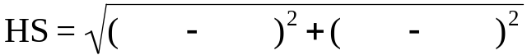 = _________ grid units = ______cm

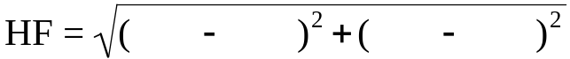 = _________grid units = ______ cm

Step 5: Convert grid units to meters, then to kilometers: Circle the google map scale used:
Map Scale: 250m::::1 grid unit = 50 m
Map Scale: 500m::::1 grid unit = 100 m
1 grid unit = __________m
Multiply each of your answers in step 4 by the conversion factor.
HT = ____________ m HS = ____________ m HF = __________ m
HT = ____________ km HS = ____________ km HF = __________ km

Step 6: Use a ruler to measure the straight-line distance between each pair of points to the nearest tenth of a centimeter.
HT = __________ cm HS = __________ cm HF = __________ cm
Compare these results with your answers in Step 4. Are the distances exactly the same? Discuss what would account for differences?

Step 7: Compare using Google Maps and a special feature called ‘Distance Measurement Tool’. Open Google Maps: Go to the feature My Maps. Click the distance measurement feature.
Follow directions and calculate each of the following straight line distances;

HT = __________ km HS = ___________km HF = ________km

Compare these results with your answers in Steps 4 and 6. Are the distances exactly the similar? Discuss what would account for differences?

Part 2: Getting Linear
In this part we write the equation of the lines that connect various points.
You can write the equation of a line when you know the y-intercept and the slope of that line. HT, HS, and HF all have the same y-intercept. What is that number?
The y-intercept for lines HS, HT, and HF is _________ .

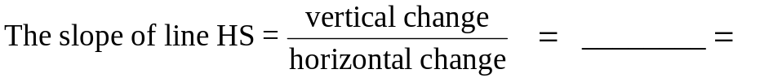
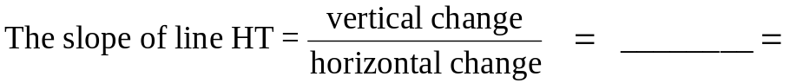
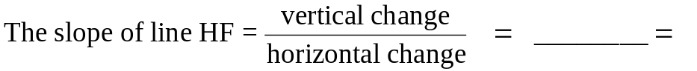

In general, the slope-intercept form for the equation of a line is
Y = __________ X + ________

Write the linear equations for;
HS: _____________________________________

HT: _______________________________

HF: _____________________________________

Challenge: Find the equation of the following lines:
TS: _____________________________________

FS: _____________________________________

GT: _____________________________________

Taxi Cab Distances:
A taxi is driving from your house to each of the 3 locations that you choose; school (S), movie theater (T), and favorite food spot (S). Assuming the taxi stays on the road, how far would the taxi drive in order to cover the distances HT, HS, and HF?
Step 1: With a highlighter, mark a route from point H to point T.
Step 2: With your pencil, number each intersection where the taxi changes direction. Your trip from point H to T might consist of the following pathway. H to 1, 1 to 2, 2 to 3, 3 to T.
Step 3: Using a ruler measure each part of the trip and record your information below.

H to 1 |  | 3 to
1 to 2
2 to 3

Total Distance HT: _________

Repeat this procedure to find the distance from H to S.
H to 1
1 to 2

Total Distance HS: _________
Repeat this procedure to find the distance from H to F
H to 1
1 to 2

Total Distance HF: _________
Questions:
1. Do you think that your estimate is accurate to the nearest mile? Nearest half mile? Nearest quarter mile? Nearest tenth of a mile?

2. What factors do you think might affect the accuracy?

3. How might you check the accuracy of your map estimate?

Google Maps has a special feature called ‘Distance Measurement Tool’. You can direct it to follow any path from point to point to point (Google Maps may choose a different path).
Consult the pathway used above, click away and record your answers.
Home to School: ___________________ km
Home to Food: ___________________ km
Home to Theatre: ___________________ km

4. Compare these results. Are the distances exactly the same? Discuss what would account for differences?

- Reflect upon the gasoline and how much use getting around your town. Write a paragraph explaining how you could reduce the amount of gasoline that you consume and approximate by what percentage you could reduce that usage.

Google My Town: Distance

Teacher Answer Key

Name:____________________________________ Class period:______
In this activity you will explore your town using distance formulas, linear algebra and Google Maps.
Step 1: Take a look at the Google map of your town. Mark the locations below on your map. Also write in their addresses in the adjacent space.
Answers will vary
- Home (H) ___________________ - closest movie theatre(T)______________

- School (S) ___________________ - McDonald’s (F) ____________________

Step 2: Overlay your map with the transparent grid. Let your home (H) be the origin (0, 0). Draw in an x-axis and a y-axis.
Step 3: Estimate the coordinates of points T, S, and F. Round to the nearest whole unit.
H (0, 0) T(_____ , _____) S ( ____ , _____) F( ____ , _____)

Step 4: Use the distance formula to find the length of each.
= _________grid units = _______cm

= _________ grid units = ______cm

= _________grid units = ______ cm

Step 5: Convert grid units to meters, then to kilometers: Circle the google map scale used:
Map Scale: 250m::::1 grid unit = 50 m
Map Scale: 500m::::1 grid unit = 100 m
1 grid unit = __________m
Multiply each of your answers in step 4 by the conversion factor.
HT = ____________ m HS = ____________ m HF = __________ m
HT = ____________ km HS = ____________ km HF = __________ km

Step 6: Use a ruler to measure the straight line distance between each pair of points to the nearest tenth of a centimeter.
HT = __________ cm HS = __________ cm HF = __________ cm
Compare these results with your answers in Step 4. Are the distances exactly the same? Discuss what would account for differences?

Step 7: Compare using Google Maps and a special feature called ‘Distance Measurement Tool’. Open Google Maps: Go to the feature My Maps. Click the distance measurement feature.
Follow directions and calculate each of the following straight line distances;

HT = __________ km HS = ___________km HF = ________km

Compare these results with your answers in Steps 4 and 6. Are the distances exactly the similar? Discuss what would account for differences?

Part 2: Getting Linear
In this part we write the equation of the lines that connect various points.
You can write the equation of a line when you know the y-intercept and the slope of that line. HT, HS, and HF all have the same y-intercept. What is that number?
The y-intercept for lines HS, HT, and HF is _________ .

In general, the slope-intercept form for the equation of a line is
Y = __________ X + ________

Write the linear equations for;
HS: _____________________________________

HT: _______________________________

HF: _____________________________________

Challenge: Find the equation of the following lines:
TS: _____________________________________

FS: _____________________________________

GT: _____________________________________

Taxi Cab Distances:
A taxi is driving from your house to each of the 3 locations that you choose; school (S), movie theater (T), and favorite food spot (S). Assuming the taxi stays on the road, how far would the taxi drive in order to cover the distances HT, HS, and HF?
Step 1: With a highlighter, mark a route from point H to point T.
Step 2: With your pencil, number each intersection where the taxi changes direction. Your trip from point H to T might consist of the following pathway. H to 1, 1 to 2, 2 to 3, 3 to T.
Step 3: Using a ruler measure each part of the trip and record your information below.

H to 1 |  | 3 to
1 to 2
2 to 3

Total Distance HT: _________

Repeat this procedure to find the distance from H to S.
H to 1
1 to 2

Total Distance HS: _________
Repeat this procedure to find the distance from H to F
H to 1
1 to 2

Total Distance HF: _________
Questions:
1. Do you think that your estimate is accurate to the nearest mile? Nearest half mile? Nearest quarter mile? Nearest tenth of a mile?

2. What factors do you think might affect the accuracy.

3. How might you check the accuracy of your map estimate?

Google Maps has a special feature called ‘Distance Measurement Tool’. You can direct it to follow any path from point to point to point (Google Maps may choose a different path).
Consult the pathway used above, click away and record your answers.
Home to School: ___________________ km
Home to Food: ___________________ km
Home to Theatre: ___________________ km

4. Compare these results. Are the distances exactly the same? Discuss what would account for differences?

5. Reflect upon the gasoline and how much use getting around your town. Write a paragraph explaining how you could reduce the amount of gasoline that you consume and approximate by what percentage you could reduce that usage.

Oil – Supply & Demand

Content Area:
Estimating values from bar graphs
Creating scatter plots
Finding a line of best fit
Solving a system of equations
Interpreting line graphs

Standards met:
NM-ALG.9-12.1
NM-ALG.9-12.3
NM-PROB.PK-12.1
NM-PROB.COMM.PK-12.2
NM-PROB.REP.PK-12.1

Time required: 30-45 minutes

Materials: (per student)
1 Ruler
graph paper
1 Calculator

Teacher Background Information: The graphs for this lesson come from the following web site: http://seekingalpha.com/article/81979-oil-s-supply-and-demand

Goals: To… Assess or review students’ understanding of how to fit an equation to a set of data, solving systems of equations, and interpreting line graphs.
Objectives: Students will…
- Estimate values from a bar graph
- Create scatter plots representing data from bar graphs
- Derive the equations for the line of best fit for given data sets
- Solve a system of linear equations
- Interpret and discuss implications of the graph of the system of equations

Procedure:
- Ask students to read the short article “Oil supply to trail demand by 2030, study predicts.”
- Lead a discussion of what supply and demand means to prices and how that is affecting the price of gas etc.

Oil – Supply and Demand: Student Worksheet

Name:________________________________Class period:_________
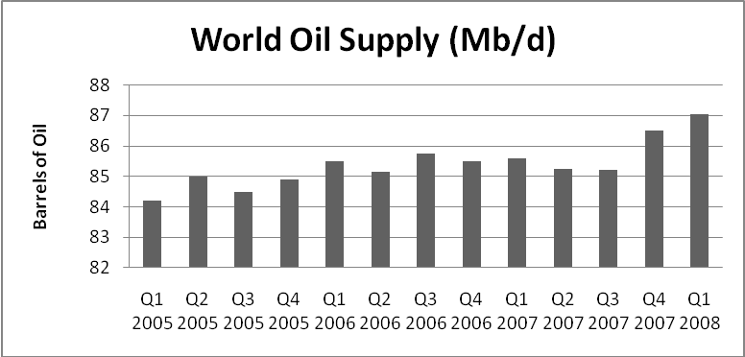
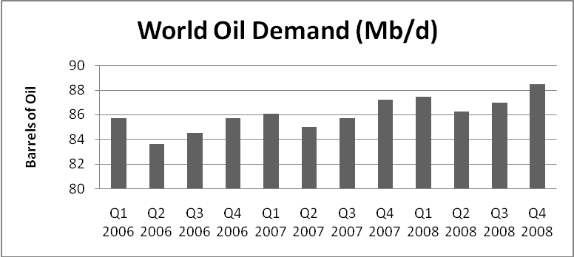

- Using the graphs above, complete the table below. The year represents the years after 2005, so that January 1, 2006 is equal to 1.0.

Quarters after 2005 | 1 | 2 | 3 | 4 | 5 | 6 | 7 | 8 | 9
Supply*
Demand*

* values are in millions of barrels/day
For problems 2 & 3, use graph paper supplied by your teacher.

2. Create a scatter plot for both the supply and the demand of oil (on the same axis).

3. Draw a line of best fit for the supply points, then draw the line of best fit for the demand points.

4. Write the equation of the line representing supply (using function notation is required).

5. Write the equation of the line representing demand (using function notation is required).

6. Using one of the methods learned in class, solve the system of equations for the supply and demand equations that you derived above.

7. What is the meaning of this solution point?

8. What consequences, concerning the price of petroleum products, can we predict for the years after this equilibrium point?

9. Discuss, with other students near you, possible actions that we as consumers can take to lessen those consequences. Write three to five of those ideas below.

Oil – Supply and Demand: Student Worksheet- Teacher Answer Key
Name: _____________________________ Class period:_________

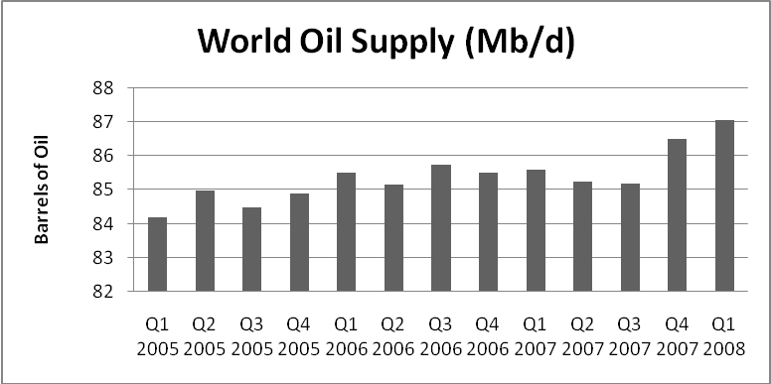

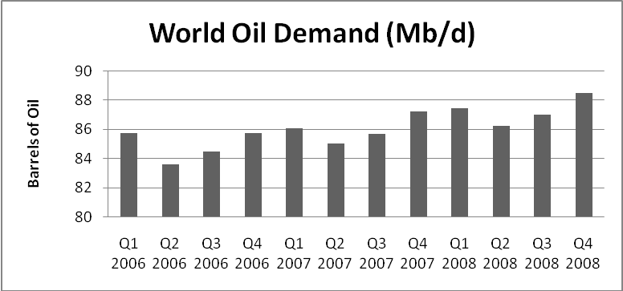
1. Using the graphs above, complete the table below. The “Quarters after 2005” represents the number of quarters after the 4th Quarter of 2005. Therefore, 3 quarters after 2005 represents “Q3 2006” in either graph.
Quarters after 2005 | 1 | 2 | 3 | 4 | 5 | 6 | 7 | 8 | 9
Supply* | 85.5 | 85.2 | 85.75 | 85.5 | 85.6 | 85.25 | 85.2 | 86.5 | 87.1
Demand* | 85.75 | 83.6 | 84.5 | 85.75 | 86.1 | 85 | 85.7 | 87.25 | 87.45

* values are in millions of barrels/day
For problems 2 & 3, use graph paper supplied by your teacher.
2. Create a scatter plot for both the supply and the demand of oil (on the same axis).

3. Draw a line of best fit for the supply points, then draw the line of best fit for the demand points.

4. Write the equation of the line representing supply (using function notation is required).
S(x) = .1492x + 84.9875
5. Write the equation of the line representing demand (using function notation is required).
D(x) = .3233x + 84.0611
6. Using one of the methods learned in class, solve the system of equations for the supply and demand equations that you derived above.
.1492x + 84.9875 = .3233x + 84.0611
0.1741x = 0.9264
X ≈ 5.321 (During the 2Q of 2007)
Y ≈ 85.78 mb/d
7. What is the meaning of this solution point?

It estimates where the world oil supply was equal to the world oil demand.

8. What consequences, concerning the price of petroleum products, can we predict for the years after this equilibrium point?

If the world oil demand continues to be higher than the world supply of oil, we can expect the cost of oil, and oil products, to increase.

9. Discuss, with other students near you, possible actions that we as consumers can take to lessen those consequences. Write three to five of those ideas below.



Oil supply to trail demand by 2030, study predicts
By Bloomberg News | July 19, 2007
NEW YORK -- Oil supplies may fall short of demand by 13 million barrels a day by 2030, according to a study led by former Exxon Mobil Corp. chairman Lee Raymond and based on forecasts from the world's largest oil companies.
Data collected from as many as 12 international oil companies showed global production may reach 105 million to 110 million barrels a day by 2030. That's as much as 11 percent below US government forecasts for 118 million barrels a day of demand. The report was approved yesterday by the National Petroleum Council, an advisory group that conducted the study in response to a request from US Energy Secretary Samuel Bodman.
"We need energy efficiency, we need to moderate the rate of growth of demand," Bodman said after the report was released. "We need diversity of suppliers and of supplies."
The oil industry, with this report, is moving closer to the analysts, hedge fund managers, politicians, and academics who have warned that global energy supplies will only get tighter and prices higher in years to come. The Petroleum Council recommends improving energy efficiency and pursuing unconventional sources of energy, including oil from tar sands and shale formations and nonpetroleum fuels such as ethanol.
The industry is "very aware of the pressures of demand growth, the impact of rising costs, and this access question," said Daniel Yergin, chairman of the consulting firm Cambridge Energy Research Associates, who helped write the study.
Access to the global oil deposits that are easiest and cheapest to tap is becoming more difficult as governments in countires such as Russia and Venezuela become less willing to turn their resources over to foreign companies.

