Equilibrium/Le Chatelier’s Principle

**HIGH SCHOOL**

**Green Chemistry & Sustainable Science**

Teacher Background Information:

Traditionally, equilibrium experiments and Le Chatelier’s Principle are illustrated using chemicals that undergo color changes as the equilibrium position shifts. Examples of several reagents that have typically been used are:

exo

(A) CoCl42- (aq) + 6H2O (l) ⮀ Co(H2O)62+ (aq) + 4Cl- (aq)

blue endo red

This experiment is used to demonstrate the effects of both temperature changes and concentration changes on an equilibrium mixture.

(B) Cr2O72- (aq) + H2O (l) ⮀ 2CrO42- (aq) + 2H+ (aq)

orange yellow

This experiment is used to demonstrate the effects of concentration changes on an equilibrium mixture.

(C) Fe3+ (aq) + CNS- (aq) ⮀ Fe(CNS) 2+ (aq)

yellow red

This experiment is also used to demonstrate the effects of concentration changes on an equilibrium mixture.

While all of these effectively demonstrate Le Chatelier’s Principle, they each utilize reagents that are toxic. In this lab activity, students will explore Le Chatelier’s Principle using non-toxic materials, while still visualizing the equilibrium shifts through color changes.

Activity 1 uses an iodine-starch complex to demonstrate the effect of temperature on equilibrium. The formation of the complex is an exothermic reaction and results in a deep purple color. The Activity 1 section of the teacher guide provides more information regarding this reaction.

In Activity 2, students evaluate the effect of pH on equilibrium using butterfly pea tea, household ammonia solution, and vinegar. When vinegar is added to the tea, the color of the solution lightens and changes from blue to purple. When baking soda is added to the tea, the solution darkens. This can be reversed, and students can change the tea solution in color to observe the shift in equilibrium.

The lab presents this reaction in the basic format of:

Tea (aq) + H+ (aq) ⮀ TeaH+ (aq)

blue purple

However, depending on the level of your students, you may prefer to share more information with them. The molecules in butterfly pea tea being considered in this experiment are a group of polyphenols called theaflavins. There are four major theaflavins found in tea, but we will only consider the reaction of theaflavin (TF-1). Theaflavin is highly stable in acidic solution but will degrade to theanaphthoquinone via the mechanism proposed by Jhoo et al.

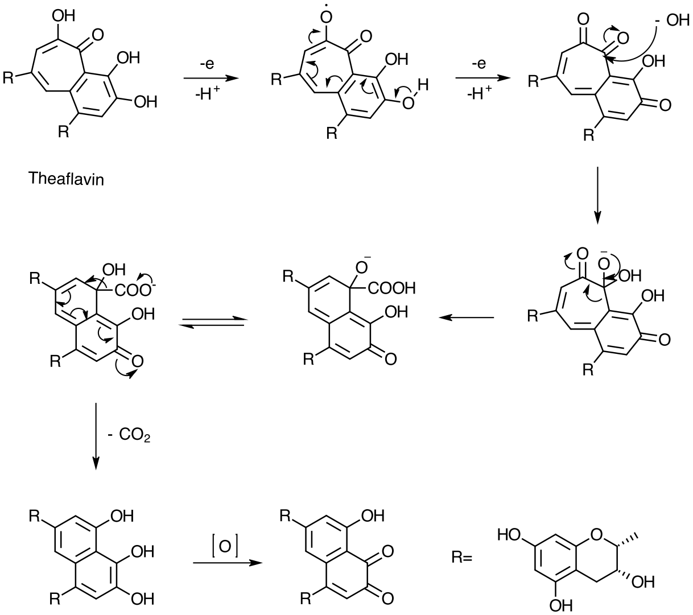

When you add vinegar (H+), the alcohol functional groups will become more protonated, allowing for the reaction solution to become lighter in color. It is important to notice the amount of -OH functional groups in the resulting theanaphthoquinone compound. This promotes the high solubility of the compounds and allows the reaction’s equilibrium to continue in the results you will observe.

**Additional Resources:**

“Stability of Black Tea Polyphenol, Theaflavin, and Identification of Theanaphthoquinone as Its Major Radical Reaction Product” by Jin-Woo Jhoo, Chih-Yu Lo, Shiming Li, Shengmin Sang, Catharina Y. W. Ang, Thomas M. Heinze, and Chi-Tang Ho. *Journal of Agricultural and Food Chemistry*, 2005, *53* (15), 6146-6150. DOI: 10.1021/jf050662d.

“Tea Tannins Part 3—Black Tea”<https://bostonteawrights.com/tea-tannins-part-3-black-tea/>

Safety Information:

Safety glasses should be used whenever working in the lab.Iodine is a minor eye irritantandvinegar and ammonia can cause skin irritation. Individuals with sensitive skin should wear gloves.

Learning Objectives: Students will…

* Explain the concept of chemical equilibrium
* Distinguish between static and dynamic equilibrium
* Understand Le Chatelier’s Principle
* Describe how to set up an experiment that is in chemical equilibrium
* Predict the effect of adding a stress to the system at equilibrium

Time Required: 45-minute class period

Materials (per group of 2–4 students):

* 6 (18 x 150 mm) test tubes
* 75 mL of butterfly pea tea
* 15 drops of vinegar
* 1 g of baking soda
* 3 drops of tincture of iodine
* Spray starch
* Hot plate/ electric kettle
* 2 (300 mL) beakers
* Ice
* 3 glass stirring rods
* Thermometer
* 2 plastic pipettes
* 2 (100 mL) graduated cylinders
* Test-tube rack
* 400 mL beaker
* 1 scoopula
* Scale

Keys for Success:

* Introduce the lesson by sharing the information in the Pre-Lab Exercise Sheet.
* On the student sheet, the balanced reactions do not include the description of color for each side of the equation. If you feel your class cannot determine this for themselves, feel free to write the color labels under the equations, as they are in the Teacher Background Information.
* Be sure to check the ingredients list when purchasing spray starch to ensure starch in one of the primary ingredients.

**NGSS Standards Met:**

HS-PS1-6: Refine the design of a chemical system by specifying a change in conditions that would produce increased amounts of products at equilibrium.

Teacher Preparation:

* Starch solution: Spray starch into a 300 mL beaker (cover the bottom of the beaker with spray or use 5-10 drops of liquid starch). Fill the remainder of the beaker with water and stir.
* Butterfly Pea tea: Prepare 1000 mL of butterfly pea tea—the darker, the better. Prepare with electric kettle and allow it to cool to room temperature.
* Additional reagents that may be used for student inquiry include black tea (substitute for the butterfly pea tea) and lemon juice (substitute for the vinegar).

Activity 1: Iodine and Starch

1. Assign pre-lab for homework and review equilibrium concepts.
2. Introduce the concept of the starch-iodine complex.
3. Using a pipette, add one drop of tincture of iodine to 30 mL of starch solution. Note the formation of a blue-black color.
4. Heat the solution to about 80 °C. Note that the blue-black color disappears. What can we deduce from this?
5. Cool the container by placing it in ice. What do we observe?
6. Discuss equilibrium with the class:

Iodine (aq) + Starch (aq) ⮀ Starch-Iodine Complex (aq)

colorless blue-black

The soluble starch acts as an indicator of molecular iodine. In the above reaction, the “shifts” in equilibrium position produced by temperature changes are in accordance with Le Chatelier’s principle. Enthalpy, or ΔH, is negative (exothermic) in the *forward* direction as written above because heat is being released. Cooling the system, or taking away heat, causes a “shift” to the right, resulting in the formation of the blue-black starch-iodine complex. Adding heat to the system causes a “shift” in the *reverse* direction (ΔH is positive) and the starch-iodine complex dissociates in an endothermic reaction, causing the system again to become clear and colorless.

Which direction is exothermic and which is endothermic? How do we explain our results?

endo

Iodine (aq) + Starch (aq) ⮀ Starch-Iodine complex (aq)

colorless exo blue-black

Activity 2: Tea

1. Each student group will prepare 75 mL of butterfly pea tea solution from a stock solution prepared by the teacher.
2. Students will then separate 25 mL into three test tubes or small Erlenmeyer flasks. One of these will be used as a control.
3. Using a pipette, add 15 drops of vinegar to one sample. Note the change in color (to a lighter purple color), compared to the control. This indicates the increase in the number of H+ ions. The number of drops of vinegar can be manipulated.
4. Using a scoopula, add 1 g of baking soda to the second sample. Note the change to a darker blue/green color compared to the control. Because the baking soda is basic, it binds the H+ ions. Again, the amount can be changed; ask students to try 3 trials and record the variables.
5. Optional: students can use the flashlight feature on their cell phones to better see the changes.
6. Discuss shifting of the equilibrium:

Tea (aq) + H+ (aq) ⮀ TeaH+ (aq)

blue purple color

Disposal Information:

* All waste is safe for disposal down the drain after neutralization.

Equilibrium/Le Chatelier’s Principle

Pre-Lab Exercise

Background Information:

Chemical equilibrium is a state of dynamic balance where the rate of the forward reaction is the same as the rate of the reverse reaction. Examples of reactions in dynamic equilibrium are:

N2  (g) + 3H2 (g) ⮀ 2NH3 (g)

2NO2 (g) ⮀ N2O4 (g)

If you look up “equilibrium,” you will find it explained using words like “state of balance.” A meter stick that is suspended at its center of gravity is said to be balanced or in equilibrium; it remains stationary, or static. Thus, this type of equilibrium is often referred to as **static equilibrium**. In other words, the entire system is not moving. Consider now the case of a man running on a treadmill. Overall, there is no change in his position. He is running forward at the same speed that the belt is moving in the opposite direction. The two opposing motions balance each other. This is an example of a type of equilibrium called **dynamic equilibrium**, as the word “dynamic” means “moving.” Another example of a dynamic equilibrium is when you walk down an escalator at the same speed as it is moving up. There is no overall change in your position because the two opposing motions are balanced.

Problem:

How can Le Chatelier’s Principle be used to predict the direction in which a system at equilibrium will shift when conditions are altered? The equilibrium system that we will study in the Pre-Lab is:

CuCl2 (aq) ⮀ Cu+2 (aq) + 2Cl- (aq) + heat

green blue colorless

1. Write out the balanced reaction between AgNO3 (aq) and CuCl2 (aq) and identify the precipitate formed.
2. For each change listed, predict the equilibrium shift using the reaction from Question 1 and your knowledge of Le Chatelier’s Principle:

|  |  |  |  |
| --- | --- | --- | --- |
| **Stress** | **Direction of shift**  (🡪, 🡨, or *no change*) | **Stress** | **Direction of shift**  (🡪, 🡨, or *no change*) |
| Raise temperature |  | Add Ag+NO3- |  |
| Lower temperature |  | Add Na+Cl- |  |

Equilibrium/Le Chatelier’s Principle

Student Lab Sheet

Activity 1: Iodine and Starch

Materials:

* Starch solution
* 1 (100 mL) graduated cylinder
* 3 (18 x 150 mm) test tubes
* Tincture of iodine
* Plastic pipettes
* Glass stirring rod
* Ice
* 2 (300 mL) beakers
* Thermometer
* Hot plate/electric kettle
* Test tube rack

Procedure:

1. Measure 60 mL of starch solution using the graduated cylinder.
2. Pour 20 mL of the starch solution into each of the three test tubes.
3. Use the plastic pipette to add 1 drop of tincture of iodine to each test tube and stir with a glass stirring rod.
4. Prepare an ice bath with ice cubes and water in a 300 mL beaker.
5. Prepare a hot water bath by heating a 300 mL beaker filled with water on a hot plate until it reaches 800C; measure the temperature with a thermometer. Alternatively, obtain pre-heated water from your teacher.
6. Place one test tube in the ice bath, one in the hot water bath, and leave one as a control.
7. Observe and record the changes that occur.

Data and Observations:

Iodine (aq) + Starch (aq) ⮀ Starch-Iodine Complex (aq)

|  |  |
| --- | --- |
| **Stress** | **Resulting color** |
| Control |  |
| Raise temperature |  |
| Lower temperature |  |

Questions:

1. What effect did heating the test tube have on the concentration of starch-iodine complex? Explain how you know this by using Le Chatelier’s Principle.
2. What effect did cooling the test tube have on the concentration of starch-iodine complex? Explain how you know this by using Le Chatelier’s Principle.
3. Which direction is exothermic? Which direction is endothermic? Explain your answer.
4. Illustrate this Le Chatelier shift with a reversible chemical reaction.

Activity 2: Tea

Materials:

* Butterfly pea tea solution
* 1 (100 mL) graduated cylinder
* 3 (18 x 150 mm) test tubes
* 1 plastic pipettes
* Vinegar
* Baking soda
* Scoopula
* Scale
* Glass stirring rod

Procedure:

1. Measure 75 mL of butterfly pea tea solution into the graduated cylinder.
2. Pour 25 mL of tea into each of the three test tubes.
3. Use a plastic pipette to add 15 drops of vinegar to one of the test tubes, stir with a stirring rod, and label.
4. Use a scoopula to weigh out 1 g of baking soda on a scale. Add 1 g of baking soda to the second test tube, stir with a stirring rod, and label.
5. Leave the third test tube as a control.
6. Observe and record the color changes that occur.

Data and Observations:

Tea (aq) + H+ (aq) ⮀ TeaH+ (aq)

|  |  |
| --- | --- |
| **Stress** | **Resulting Color** |
| Control |  |
| Vinegar addition |  |
| Baking soda addition |  |

Questions:

1. In this activity, how could you determine whether or not a change occurred in equilibrium? Explain.
2. For each reaction in Activity 2, demonstrate how each change can be explained by Le Chatelier’s Principle. Be specific about where the chemical was added (the stress) and its impact on the other components of the Tea Equilibrium.

Vinegar (Acetic acid, HC2H3O2): Tea (aq) + H+ (aq) ⬄ TeaH+ (aq)

Baking soda (NaCHO3): Tea (aq) + H+ (aq) ⬄ TeaH+ (aq)

1. Traditionally, Le Chatelier’s Principle might be demonstrated using cobalt ions. Explain why the activity you completed is a greener reaction. Cite at least one of the 12 green chemistry principles with your justification.

Equilibrium/Le Chatelier’s Principle

Teacher Answer Key

Pre-Lab Exercises

Problem:

How can Le Chatelier’s Principle be used to predict the direction in which a system at equilibrium will shift when conditions are altered? The equilibrium system that we will study in the Pre-Lab is:

CuCl2 (aq) ⮀ Cu+2 (aq) + 2Cl-(aq) + heat

green blue colorless

1. Write out the balanced reaction between AgNO3 (aq) and CuCl2 (aq) and identify the precipitate formed.

Molecular Equation: 2AgNO3 (aq) + CuCl2 (aq) 🡪 2AgCl (s) + Cu(NO3)2 (aq)

Net Ionic Equation: 2Ag+ (aq) + 2Cl- (aq) 🡪 2AgCl (s)

1. For each change listed, predict the equilibrium shift using the reaction from Question 1 and your knowledge of Le Chatelier’s Principle:

|  |  |  |  |
| --- | --- | --- | --- |
| **Stress** | **Direction of shift**  (🡪; 🡨; or *no change*) | **Stress** | **Direction of shift**  (🡪; 🡨; or *no change*) |
| Raise temperature | 🡨 | Add Ag+NO3- | 🡪 |
| Lower temperature | 🡪 | Add Na+Cl- | 🡪 |

Activity 1: Iodine and Starch

Questions:

1. What effect did heating the test tube have on the concentration of starch-iodine complex? Explain how you know this by using Le Chatelier’s Principle.

Heating the test tube turned the blue-black solution to clear and colorless, indicating that the reaction shifted its equilibrium to the left. Le Chatelier’s Principle says that a reaction will shift its equilibrium to counteract a stress added to a system. In this case, the stress was heat and the system reacted by undergoing the endothermic reaction to separate the starch-iodine complex.

1. What effect did cooling the test tube have on the concentration of starch-iodine complex? Explain how you know this by using Le Chatelier’s Principle.

Cooling the test tube increased the blue-black color, indicating that the reaction shifted its equilibrium to the right. Le Chatelier’s Principle says that a reaction will shift its equilibrium to counteract a stress added to a system. In this case, the stress was cooling and the system reacted by undergoing the exothermic reaction to form the starch-iodine complex.

1. Which direction is exothermic? Which direction is endothermic? Explain your results.

Because the blue-black color decreased as heat was added to the system and increased when the test tube was cooled, it can be concluded that heat is a product of the chemical reaction in the forward direction. This indicates that the reaction is exothermic in the forward direction and endothermic in the reverse direction.

1. Illustrate this Le Chatelier shift with a reversible chemical reaction.

Iodine (aq) + Starch (aq) ⮀ Starch-Iodine Complex (aq) + Heat

or

endo

Iodine (aq)+ Starch (aq) ⮀ Starch-Iodine complex (aq)

colorless exo blue-black

Activity 2: Tea

Questions:

1. In this activity, how could you determine whether or not a change occurred in equilibrium? Explain.

Color change between dark brown and light brown indicates the change in concentration in H+ ions. A change in concentration of H+ ions triggers a response from a change in equilibrium.

Tea (aq) + H+ (aq) ⮀ TeaH+ (aq)

Blue Purple color

Adding acid (vinegar, lemon juice, etc.) will increase the H+ ions, thus causing the blue color to lighten to shift in the direction of products.

Adding base (baking soda) increases the amount of conjugate base (TeaH+) and causes ashift in the equilibrium in the direction of the reactants.

1. For each reaction in Activity 2, demonstrate how each change can be explained by Le Chatelier’s Principle. Be specific about where the chemical was added (the stress) and its impact on the other components of the Tea Equilibrium.

Vinegar (Acetic acid, HC2H3O2): Tea (aq) + H+ (aq) ⬄ TeaH+ (aq)

Blue Purple color

Adding vinegar (or lemon juice) will increase the H+ ions, thus causing the blue color to lighten to shift in the direction of products.

Baking soda (NaCHO3): Tea (aq) + H+ (aq) ⬄ TeaH+ (aq)

Blue Purple color

Adding NaCHO3 increases the amount of conjugate base (TeaH+), thereforeshifting the equilibrium in the direction of the reactants. The color will change back to blue, and may even become a darker blue or green with additional baking soda added.

1. Traditionally, Le Chatelier’s Principle might be demonstrated using cobalt ions. Explain why the activity you completed is a greener reaction. Cite at least one of the 12 green chemistry principles with your justification.

This lab does not use cobalt ions, which are heavy metal ions that require special processing for recovery and disposal. This lab uses household chemicals that can be poured down the sink. These are the principles (of the 12) that can be cited as justification for the fact that this lab is inherently greener:

[Prevention](https://www.acs.org/content/acs/en/greenchemistry/what-is-green-chemistry/principles/gc-principle-of-the-month-1.html)  
It is better to prevent waste than to treat or clean up waste after it has been created. This lab uses safer chemicals that prevent pollution.

[Inherently Safer Chemistry for Accident Prevention](https://www.acs.org/content/acs/en/greenchemistry/what-is-green-chemistry/principles/green-chemistry-principle--12.html)  
Substances and the form of a substance used in a chemical process should be chosen to minimize the potential for chemical accidents, including releases, explosions, and fires. The chemicals chosen for this lab are relatively safe and were chosen to reduce hazards in terms on exposure to toxic cobalt ions.