

**MIDDLE SCHOOL**

**Biotechnology**

**Who’s Your Daddy?: Finding the Father**

**Teacher Background:**

Scientists use a technique called gel electrophoresis to look at a DNA fingerprint. The DNA separates into bands and these bands form different lengths. Every organism, with the exception of identical twins, has a different DNA fingerprint.

**Goal:** To determine the identity of the father of Sparky’s kittens by comparing multiple DNA fingerprints.

**Objective:** Students will…

* View examples of DNA fingerprints to determine which male fathered Sparky’s kittens.
* Materials: (per group)
* Overhead of a kitten’s DNA fingerprint (or a copy for each group)
* Copy of the Possible Fathers’ DNA fingerprints (one for each group)

**Time Required:** 15 minute class period

**Standards Met:**

* Science and Technology Standards: Understanding about science & technology
* Life Science Standards: Reproduction & heredity

**Procedure:**

* Remind students about gel electrophoresis
* Explain that Furry Friends was able to get a sample of a kitten’s DNA. (ask the students how they think that was accomplished)
* Show (or pass out) the overhead of the kitten’s DNA gel electrophoresis fingerprint.
* Ask the students to look over their Mapping the Males data to refresh their memories on their hypothesis on who the father is.
* Pass out the Possible Fathers’ DNA sheets.
* The students should look over the DNA fingerprints or bands to determine who the father is.

*These DNA fingerprints are just examples and are not from cats. They are used purely as a simulation so that students will see how DNA fingerprints are all quite similar.*

**Assessment:**

* Accurate determination of father



**Who’s Your Daddy?: Finding the Father**

Kitten DNA

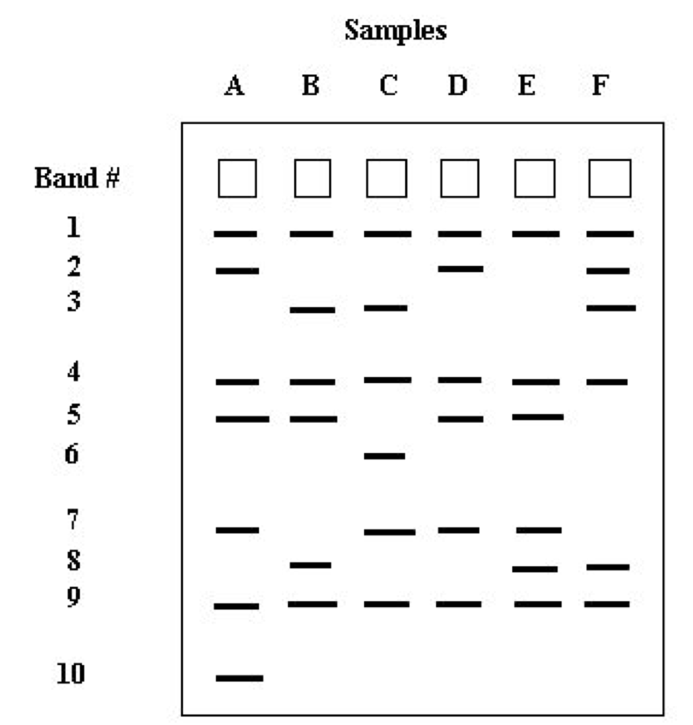

Who is the father? ________________________________

Was your original hypothesis correct? _________________

**Who’s Your Daddy?: Finding the Father**

Male Cats

Carson DNA Lucky DNA

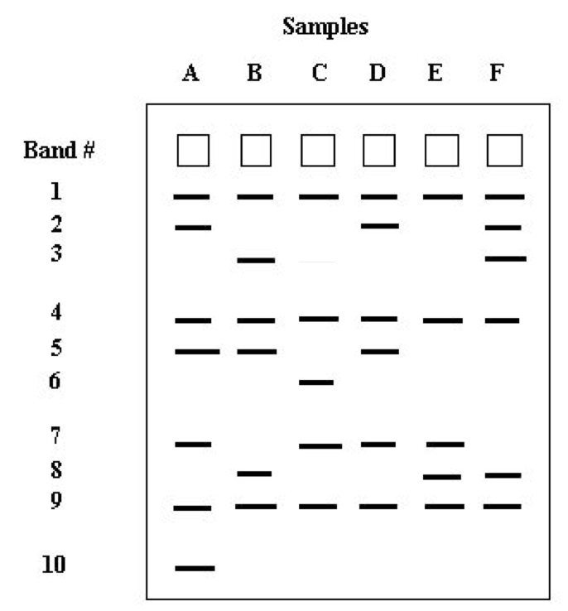 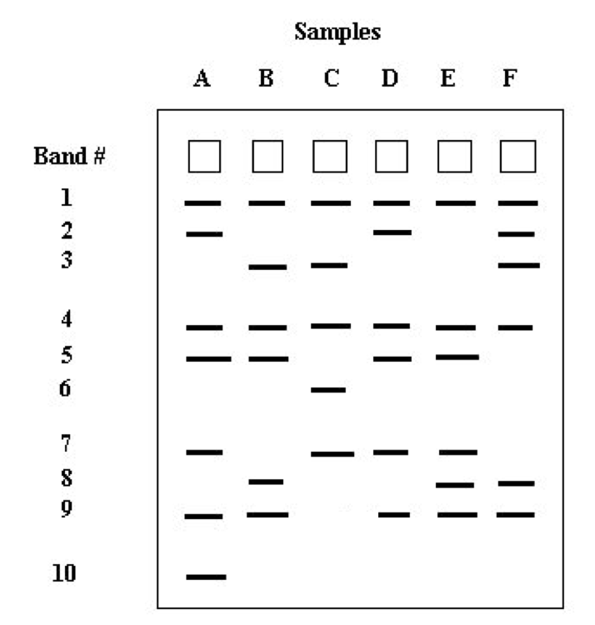

Tuga DNA

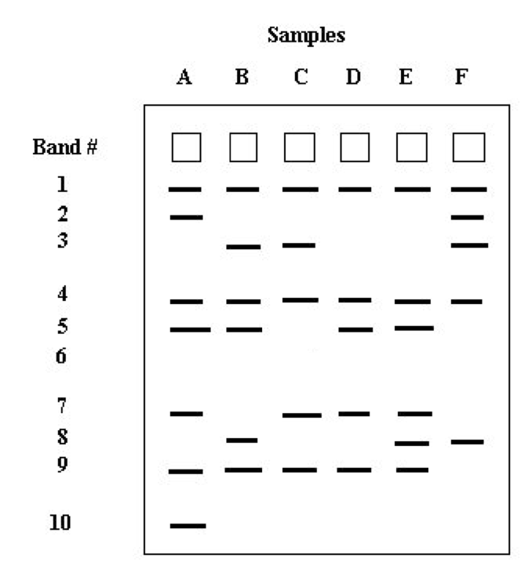

**Who’s Your Daddy?: Finding the Father**

**Answer Key**

Kitten DNA



Who is the father? ________Lucky_________________

Was your original hypothesis correct? _Answers will vary_____

Lucky has one “fingerprint” that differs from the kitten

Carson has two “fingerprints” that differ from the kitten

Tuga has three “fingerprints” that differ from the kitten