 

**MIDDLE SCHOOL**

**Math & Engineering**

**The Final Floor**

**Teacher Background Information:** To move to a final floor plan, designers and architects utilize all the information they have gathered as well as their large bubble diagrams. Floor plans serve as an invaluable tool for designers, architects, engineers, and the skilled trades people who build models as well as the final product. Working with the dimensions found on these floor plans, these professionals are able to determine how much of a particular product is needed as well as how to construct it.

**Goals:** To draw a final floor plan within the given specifications

**Objectives:** Students will…

* Identify appropriate room size
* Understand the proportion of rooms

**Standards met:**

Geometry:

* Draw geometric objects with specified properties, such as side lengths or angle measures
* Use two-dimensional representations of three-dimensional objects to visualize and solve problems such as those involving surface area and volume

Measurement:

* Select and apply techniques and tools to accurately find length, area, volume, and angle measures to appropriate levels of precision

ITEA STL’s 1, 2, 8, 11, & 13

**Time required:** 2 - 45 Min. Class Period

**Materials:**

* 30 Rulers
* 30 copies “The Final Floor – Student Sheet”
* 30 pieces of 8½” x 11, ¼” graph/grid paper (per student)
* Transparency of sample floor plan

**Procedure:**

* Using the overhead, show the sample floor plan
* Remind students to use their bubble plans to inform their final floor plans
* Check student work to ensure their plans are to scale
* Have students place their final floor plans in their portfolios

**Assessment:**

* Final floor plan correctly drawn to scale

**The Final Floor – Sample Floor Plan**

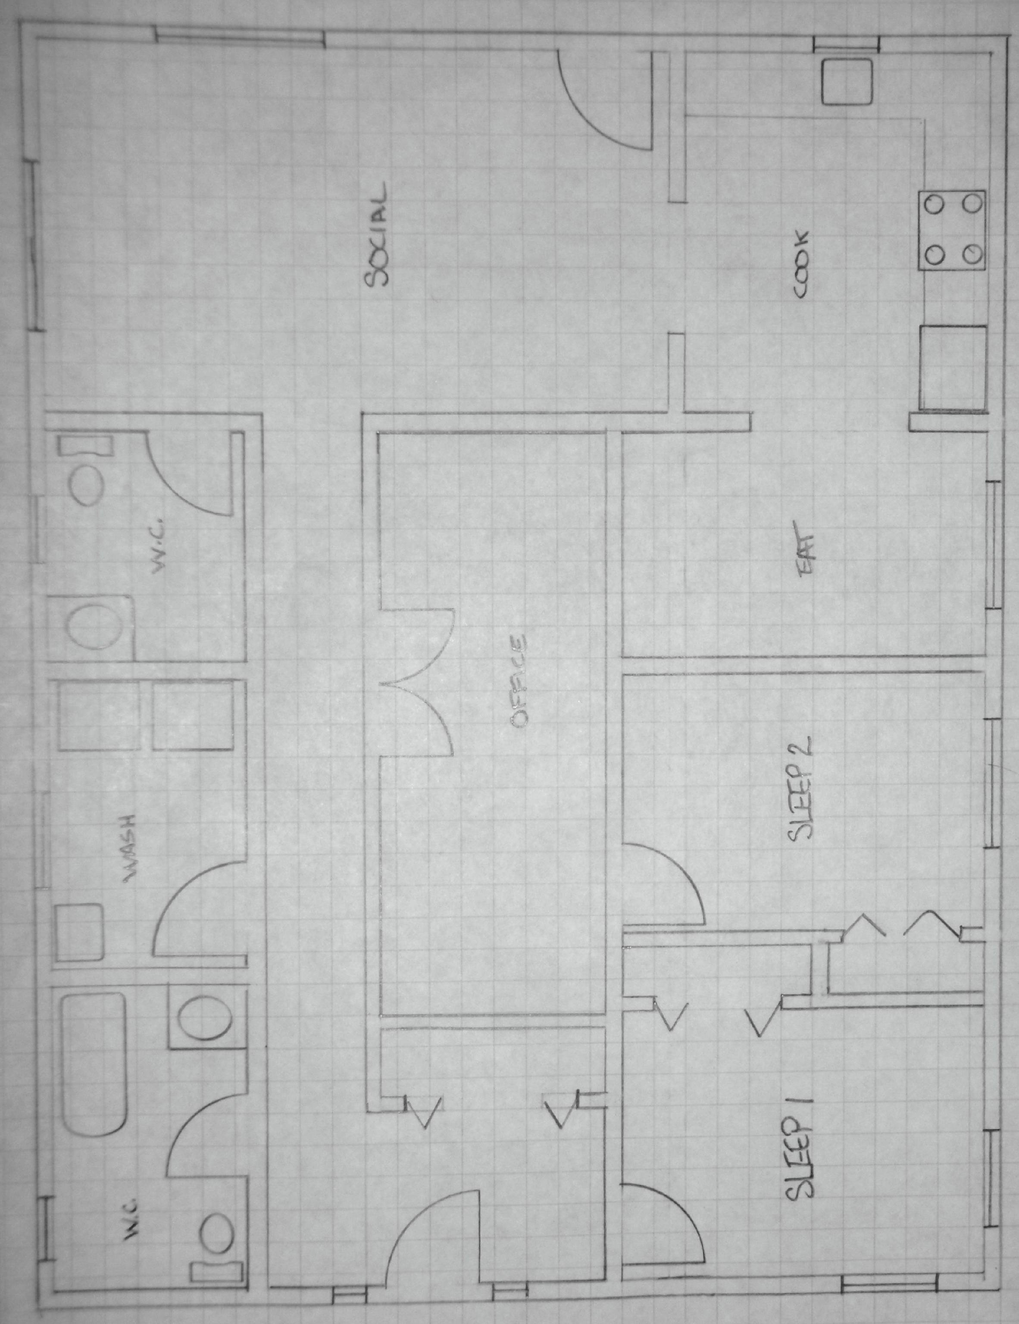

**The Final Floor – Student Sheet**

Directions: Draw a scaled representation of your floor plan

Procedure:

1. Using a ruler, determine how big one square is on your graph paper: ________________________
2. You must use the scale ¼” = 1 ft.
3. Write an equivalent statement to show the relationship between 1 box on the graph paper and a dimension of your house. _______________________________________________
4. Refer to your draft plans and intended occupant information in order to draw your house plan to scale on the graph paper
5. Draw!
6. Label the dimensions of each room
7. Write the name of each room (bedroom, living space, etc.)