 

**MIDDLE SCHOOL**

**Math & Engineering**

**Build-A-Math**

**Teacher Background Information:**Teachers need to walk students through conversions and amount of materials

**Goals:** To apply the concepts of scale and conversion to the house building

**Objectives:** Students will…..

* Calculate how much of the building material is needed to create 3-D structure
* Build a 3-D structure to scale

**Standards met:**

Connections:

* Recognize and apply mathematics in contexts outside of mathematics

Numbers & Operations:

* Work flexibly with fractions, decimals, and percents to solve problems
* Select appropriate methods and tools for computing with fractions and decimals, and apply the selected methods

**Time required:** 45 minute period

**Materials (for 30):**

* 1 small white board & dry erase marker per group
* 1 piece of cardboard, at least 5” x 6” in size, per group

**Prep:**

* Organize house building materials (see “Implementation Options for Teachers”)

**Procedure:**

* Have students get out their plans
* Tell them that today they will begin building their houses
* Give each group 1 piece of cardboard. Explain that this will be the base of the house.
* Optional: Have students tape or glue the floor plan onto their piece of cardboard.
* Review the types of materials students will be able to use to complete the building
* Give students whiteboards and markers
* On the top of the board, have students write:
* 1/8 inch = 1 ft.
* On the overhead or board, model the materials calculations for a foundation. (see “Teacher Example” on the next page)
* Tell students that they need to calculate how much material they need for their houses
  + You may want to do this in stages. Have students begin with the foundation, complete those calculations, get them approved by the teacher, obtain materials, build.
  + For the foundation, you may want to simply give the students a piece of construction paper to serve as the foundation, instead of building. This saves on materials and simplifies the process. Students should glue the paper to their base before building the walls
    - Green construction paper = ICFs
    - Blue construction paper = Concrete
    - Red construction paper = Treated Wood
  + Repeat the process for walls (remind students that they need to consider windows!)
* Optional: You may want to have students build 2 gable end walls to support their roofs. See the example on the next page to walk students through the process. You also may want to show students a gable wall, place materials like rulers, protractors, etc, and let your students determine how to complete a roof pitch!
* One student from each group should bring the white board showing their calculations
* If the calculations are correct, students may get the materials necessary and begin building

**Assessment:**

* White board calculations calculating the correct amount of materials

**Build-A-Math: Teacher Example for Foundation**

1/8 inch = 1 ft.

Complete the questions below using the figure to the left. Remember! The figure is drawn to ¼ inch =1 foot scale. Your calculations need to be 1/8 inch = 1 foot scale.

Calculate the perimeter *30 + 30 + 40 + 40 = 140*

Convert to 1/8 inch = 1 foot scale *140/2 = 70*

Convert your depth to 1/8 inch = 1 foot scale *8 feet deep/2 = 4 ft.*

Multiply the perimeter x the depth (4 ft.) *70 x 4 = 240 ft.*

40 ft.

30 ft.

If you are using cookies to build:

* The length of a cookie is twelve ¼ inch squares
  + The foundation needs **70** squares (1/8 inch)
  + 70 squares /12 squares per cookie = 5.83
  + Round up to 6 cookies
* The depth is four ¼ inch squares
  + The foundation needs **4** squares (¼ inch)
  + 4 squares /4 squares per cookie= 1
  + The foundation will be 1 cookie deep
* **Total cookies needed for foundation = 6**
  + 6 cookies for perimeter x 1 cookie deep

**Build-A-Math: Steps for Building a Gable Wall**

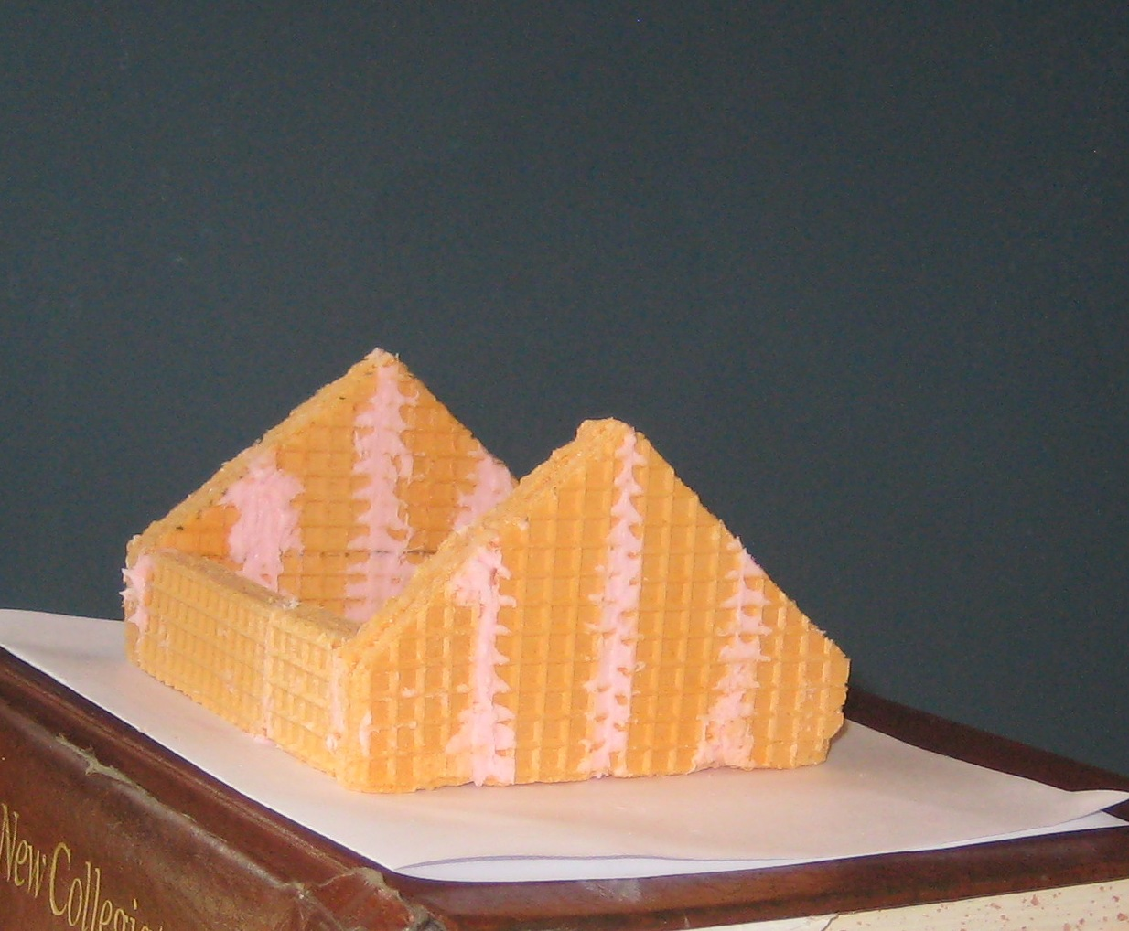

Gable End Wall

Bearing Wall

1/8 inch = 1 ft.

1. Determine which 2 walls will be the end walls of your house.
2. On a piece of graph paper, draw one of these walls to scale.
3. These walls will be the gable walls and need to be extended in order to hold your roof. See picture.
4. Determine the half-way point of the length of your walls.
5. Place a dot at the half-way point on the bottom and top of your wall.
6. Using a ruler, determine how high above the wall you would like your roof to extend. This will decide the pitch of your roof. The higher you go, the steeper the pitch.
7. Line your ruler up with the dots indicating the middle of your wall. At the top of this, place a dot.
8. From the top dot, use a ruler to measure a diagonal line down one of the roof. Have your line meet with the side of the house.
9. Do the same for the other side.
10. Cut out the figure from the graph paper and use it as a template for your final gable end walls.