**Enthalpy of Combustion**

**HIGH SCHOOL**

**Green Chemistry & Sustainable Science**

**Replacement lab:** This lab replaces the following traditional reaction.

Mg + 2HCl 🡪 MgCl2 + H2 and MgO + 2HCl 🡪 MgCl2 + H2O

**Teacher Background Information:**

* Introduce the formula to calculate the thermal heat of water:

q= mc ∆T

* Introduce the formula to calculate the heat of combustion of a hydrocarbon:

Thermal Heat of Water

∆m of candle

**Safety Information:**

* Discuss safety procedures related to heated waxes, and especially to wear goggles at all times during the lab.

**Educational Goals:** To understand through an investigation, the molar heat of combustion of paraffin, C25H52, (a non-renewable resource) compared to soy wax (a renewable feedstock)

**Student Objectives:** Students will…

* Measure the thermal heat absorbed by water
* Measure the heat of combustion of paraffin and soy wax
* Calculate the molar heat of combustion of paraffin

**Materials:** For each lab group (2 – 3 students)

* 1-Aluminum can
* 1-Glass rod
* 1 -Ring with ring stand
* 1-Graduated cylinder (100ml)
* Ice Cold water (100ml)
* Thermometer
* Balance
* Paraffin tea light candle
* Soy wax tea light candle

**Time Required:** 1 x 80-minute block or 1 -2 x 45 – 60-minute class period

**Standards Met:**

* **HS-PS1-4.** Develop a model to illustrate that the release or absorption of energy from a chemical reaction system depends upon the changes in total bond energy.
* **HS-PS3-1.** Create a computational model to calculate the change in the energy of one component in a system when the change in energy of the other component(s) and energy flows in and out of the system are known.

**Key Terms**: enthalpy of combustion, renewable versus non-renewable energy sources

**Teacher Prep/Keys for Success:**

* To make soy candles, take the paraffin candle out of the metal mold. Remove the wick. Heat the soy wax in a pourable container (measuring cup) in a microwave. Place the wicks back into the empty tins. Pour the soy wax over the wick leaving a few millimeters space at the top. Allow to completely cool, preferably overnight.
* Be sure that the water in the aluminum can is very cold, at least 10°C below room temperature, this ensures that students will burn a sufficient amount of wax to get meaningful data.

**Heat of Combustion of Paraffin and Soy Wax Student Lab**

**Introduction:** The quantity of heat released when a given amount of a substance burns is called the heat of combustion. The amount of heat released when one mole of that substance is burned is called the molar heat of combustion. These measurements are usually taken at thermodynamic standard conditions (298 K and 1 atm), and it is symbolized by ∆Hocomb.

**Using the materials listed, follow the procedure below and complete the lab table.**

**Materials**

* 1-Aluminum can
* 1-Glass rod
* 1 -Ring with ring stand
* 1-Graduated cylinder (100ml)
* Ice Cold water(100ml)
* Thermometer
* Balance
* Paraffin tea light candle
* Soy wax tea light candle

**Procedure:**

* Mass the aluminum can and record. Put a glass rod through the pop top and support on a ring and stand as shown in the diagram.
* Record the room temperature
* Pour approximately 100 mL of ice cold water into the can. Be sure that no ice is transferred into the can with the water.
* Mass your candle and record the mass.
* Light your candle and place it under the can as close to the can as possible without putting the candle out.
* Heat the water so that the temperature is raised equally above room temperature as it was below. (Ex. Water is 10oC to start, room temperature is 22oC must heat until 34oC is reached)
* Quickly and carefully blow out the candle, being very cautious not to splash paraffin.
* Let the candle cool to solidify.
* Mass the candle again and record.
* Calculate the mass of candle burned.
* Record the change in temperature of the water in your data table.
* Complete the calculations

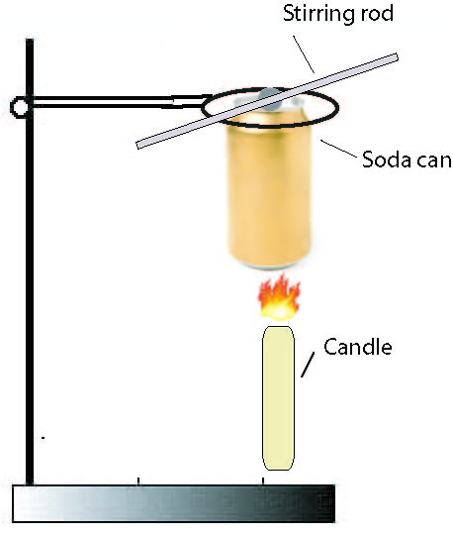

**Data Table: Paraffin Wax Soy Wax**

|  |  |  |
| --- | --- | --- |
| Mass of aluminum can |  |  |
| Mass of aluminum can and water |  |  |
| Mass of water |  |  |
| Room temperature |  |  |
| Initial mass of candle  . |  |  |
| Initial temperature of water |  |  |
| Final temperature of water |  |  |
| Final mass of candle |  |  |
| ∆T of water |  |  |
| Heat gained by water  q= mc∆T |  |  |
| Heat of combustion of the candle =  Thermal Heat gained by Water ∆Mass of candle |  |  |
| Molar heat of combustion of paraffin (kJ/mol) |  |  |

**Questions:**

1. How does your experimental heat of combustion of paraffin (kJ/g) compare with the heat of combustion of soy (kJ/g)?
2. What is the molar mass of paraffin, C25H52?
3. How does your theoretical heat of combustion of paraffin (kJ/g) compare with the heat of combustion of soy (kJ/g)?
4. As a consumer of energy, which is the more useful quantity to you, heat of combustion (kJ/g) or molar heat of combustion (kJ/mol)? Explain your answer.
5. This lab has several sources of error. List as many as possible. Suggest possible corrections for these errors.
6. Write a balanced equation for the burning of paraffin.
7. Using the data from the lab compare the pro’s and con’s of using the energy produced from Soy wax, a renewable resource, to petroleum based paraffin.
8. Write a paragraph which explains which principles of green chemistry this lab adheres to and which ones it may not. Consider the idea of using food for fuel.